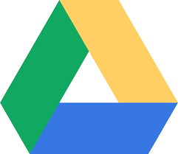Drive32
Vision
“The technology vision for Blackduck#32 (Drive32) is to prepare students to be vocationally and post-secondary prepared. Blackduck will open the doors of opportunity for students to create, collaborate, communicate, think critically and become innovative in today’s world.”

- Pieces of the Process
  - Robust Staff Development
  - 1:1 Device Implementation (Plan developed through research, reflection and evaluation of process)
    - Chromebooks for High School
    - Android Tablets (Learnpads) for Elementary
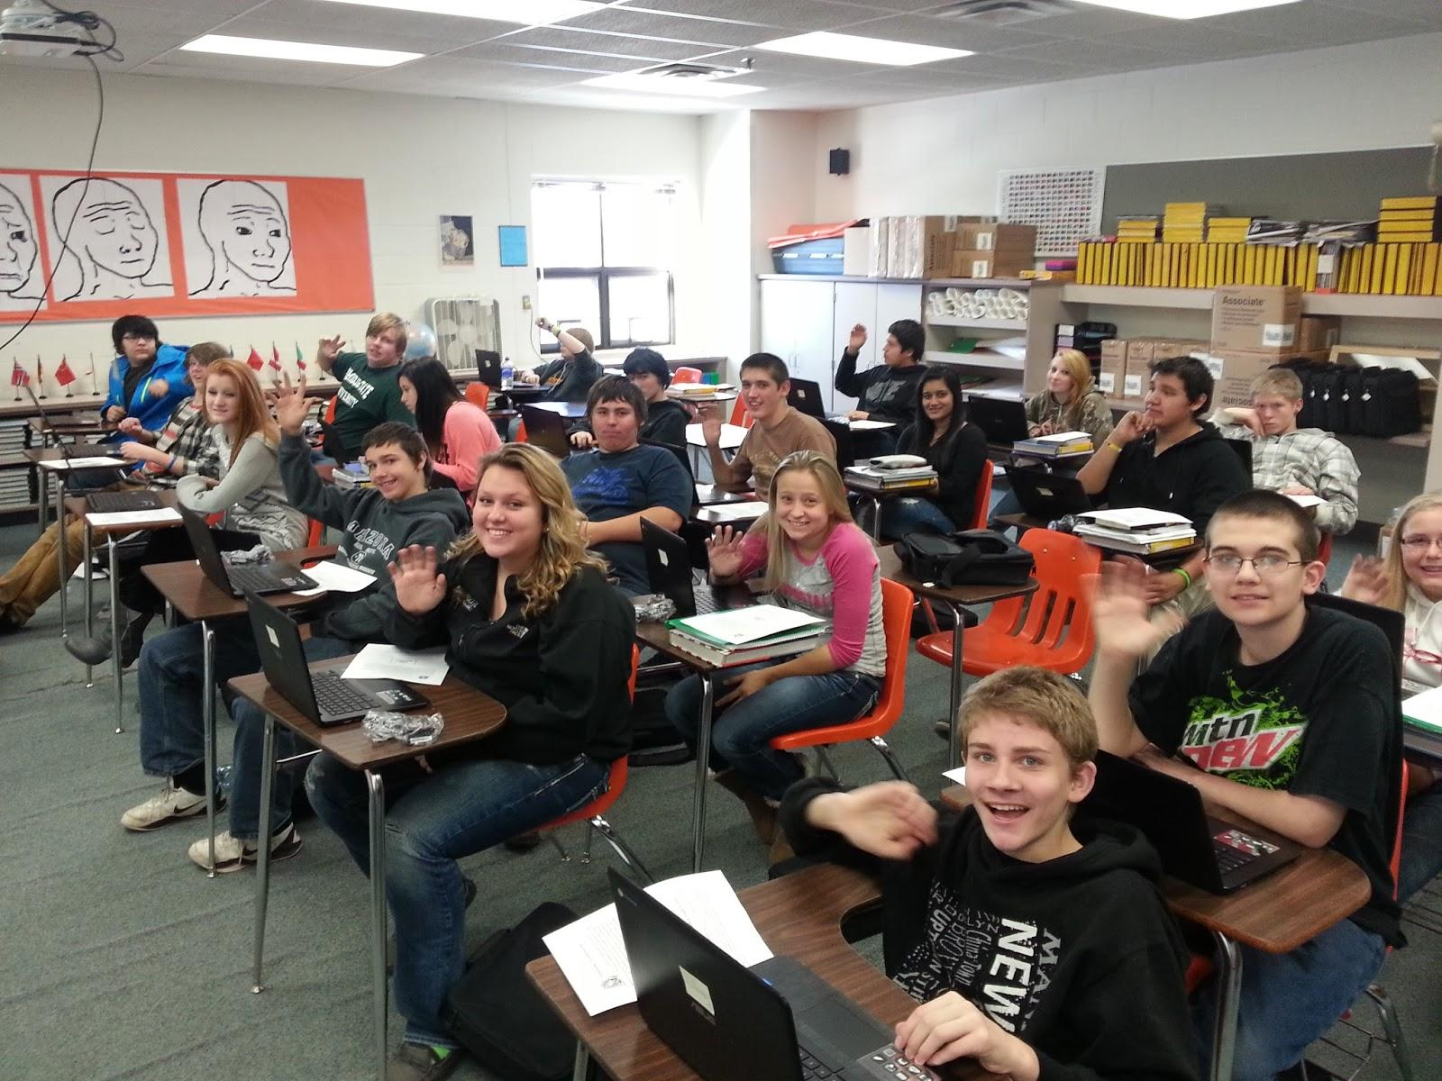
  - Technology Curriculum
    - Keyboarding
    - Digital Citizenship
    - Google Drive
  - Network Upgrading
    - Hardware
    - Software
    - Device/Content/User Management
      - Google Apps for Education
      - GoGuardian

Drive32
1:1 Rollout Model

Steps:
- Grade-level implementation
- Debrief, evaluation, reflection, documentation
- Make adjustments
- Make requisition
- Repeat process

Timeline
- Chromebooks (High School)
    - Fall 2014 - Grades 9-10
    - Winter (1) 14-15 - Grade 7
    - Spring 15
      - Possible Last Phase - Grades 8, 11, & 12
- Learnpads or Chromebooks (Elementary)
    - Fall 2014 - Grades 2-3 (Learnpads)
    - Winter (1) 14-15 - Grade 6 (Chromebooks)
    - Spring 15
      - Possible Last Phase - Grades 4 & 5
    - K-1 Will begin to use iPads

Drive32
1:1 Rollout Reflection 1
In the fall of 2014, through the generous funding of the Clubb Trust, Blackduck ISD#32 implemented 1:1 devices with Grades 2-3 (Learnpads) and Grades 9-10 (Chromebooks). The following outline demonstrates the process of implementation and necessary adjustments made for future rollout.
- Chromebook Rollout
  - Process
    - Pre
      - Device/User Management
        - Google Apps for Education Domain set up
        - Created User accounts for K-12 staff and affected students
        - Enrolled each device in device management
        - Established a need for a content management system (GoGuardian) ($7/Device/year)
        - Documented Serial Numbers, Case Numbers, and user accounts.
      - Professional Development
        - Technological Leadership Development
          - Pete Ofstedal - TIES
          - Deb Sandvig - Northwest Service Coop, TIES
          - Josh Grover - Northwest Service Coop, TIES
          - Nate Lien - TIES
          - Tom Liapis (TIES)
          - Alecia Moore (TIES)
        - Staff Development Provided
          - Google Chrome Trainings provided to all staff (Grover, Sandvig, Lien)
          - Send others to TIES conference
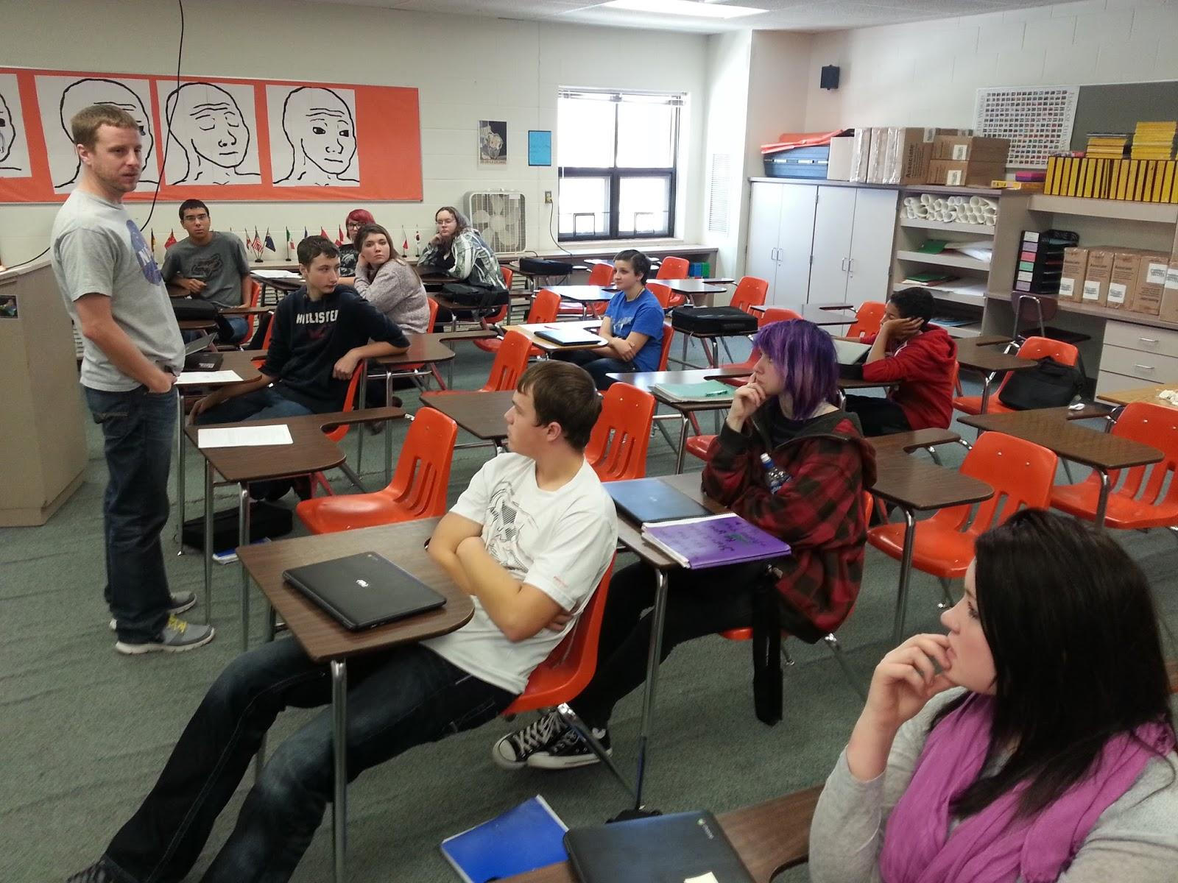
            - Tom Liapis, Alecia Moore, Jannessa Moris, & Leslie Frosaker

    - During
      - Rollout - November, 2014
        - Grover, Lien, Ofstedal on hand in the classroom
        - 1 day for approximately 100 devices
        - Issues
          - None of consequence
          - User/Student Error
      - Device/User management
        - Monitored usage through GoGuardian (See Figure 1.1)
        - Trained other staff on a case-by-case bases with the help of Deb Sandvig, Pete Ofstedahl, Joshua Grover, and Nate Lien
    - Post (Reflection)
      - Rollout -
        - Researched and established a need to readjust who gets the devices next.
          - Based on research and investigation, the decision was made to do bottom up/top down implementation.
          - Staff preparation played a large factor in this decision as well
        - Communication
          - Based on other models, it is evident that public communication regarding information and implementation is very important
          - It is the vision to provide information to the public online, in person, or via mail
        - Device/User Management
          - A need was established to keep track and organize password. They will be furnished to parents to promote involvement.
          - Whitelist/Blacklist
            - Compiling a list with teacher guidance of blocked and unblocked websites
            - Constantly evaluating vision for what students should be able to have access to
            - Evolving Concept

          - Email
            - Email will need to migrate to Gmail as a result of the move to Google apps for education
            - To be finished by the end of 2014
            - Grades 8-12 will have access
              - Age Limited to children 13 and up
        - Hardware
          - Some concern over durability
          - Asus Chromebooks are holding up well, however
          - Established a need to evaluate insurance for the devices (Lost four to accidental damage)
          - Establishing a vision for student repair curriculum
          - Current case size may need to be reduced
        - Culture
          - Constantly monitoring the effect of the Chromebooks on the culture and dynamics within the organization
          - So far, positive impacts have been observed with few concerns. Students are using:
            - Collaboration
            - Creativity
            - Critical Thinking
            - Innovation
      - Professional Development
        - Google Landscape
          - The district has established a need to move toward total Google integration
          - This was driven by the choice of using Chromebooks plus availability (and cost) of GAFE
        - Back-up Initiative to Drive to prevent lost data on physical hardware
        - Google Training
          - Encouraging Google Certification for some of our teachers

      - Key Adjustments
        - Grade-level implementation - bottom up/top down
        - Communication to the public will be improved
        - Tracking Passwords
        - Continue to evaluate usage rights
        - Migrating email to Gmail
        - Evaluating options for cases
        - Evaluating options for hardware
        - Pursuing repair process

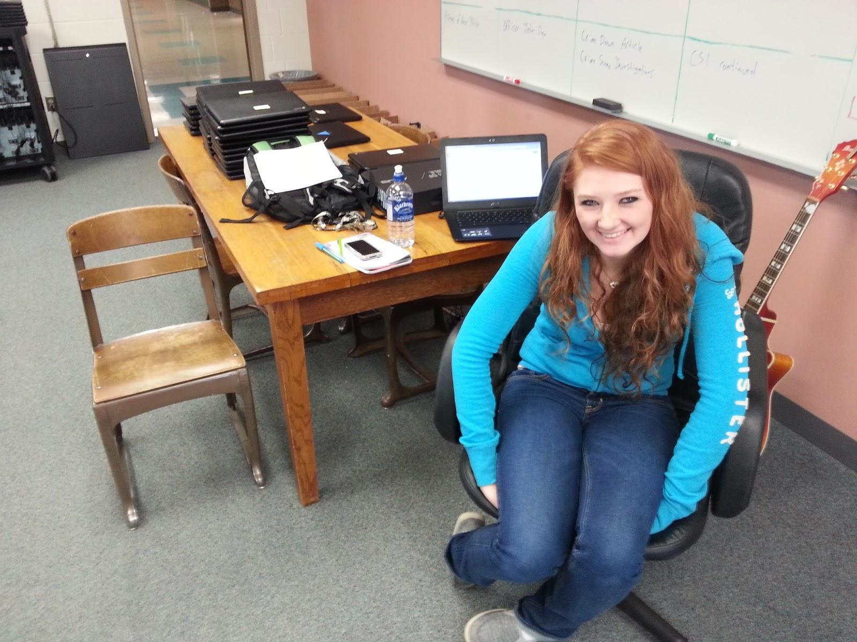

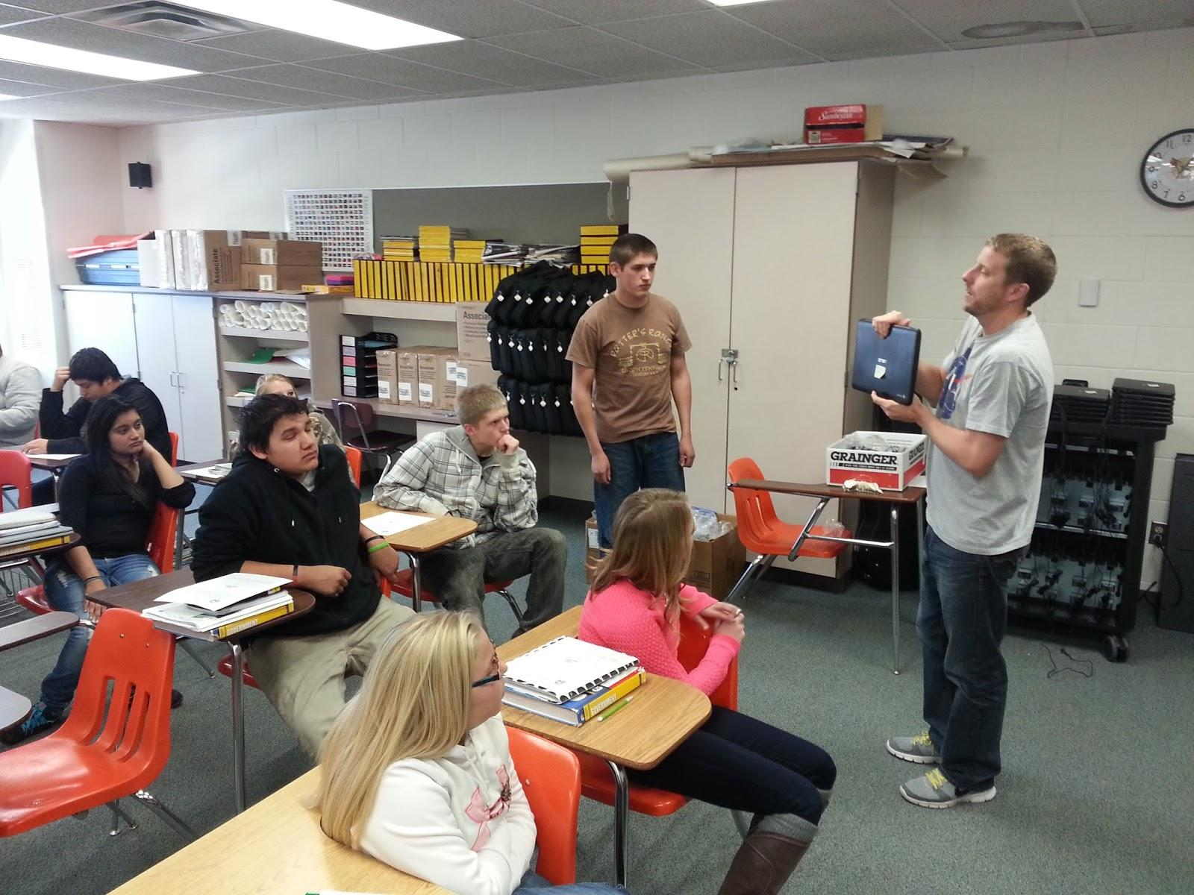

- Learnpad Rollout
  - Process
    - Pre
      - Device/User Management
        - Managed by Learnpad Teacher
      - Professional Development
        - Technological Leadership Development
          - Tom Liapis (TIES)
          - Alecia Moore (TIES)
          - Leslie Frosaker (TIES)
          - Jannessa Morris (TIES)
      - Staff Development Provided
        - Google Chrome OS, Google Apps for Education, and Google Architecture Trainings provided to all staff (Grover, Sandvig, Lien)
        - Deb Sandvig & Pete Ofstedal Received Google Trainings at TIES.
    - During
      - Rollout - November, 2014
        - Tech setup very simple. Teachers bear more of the setup burden in setting up their content.
        - No major issues. Rollout went quite smoothly.
      - Device/User management
        - Monitored and managed through Learnpad Teacher
        - Teachers manage content 100%
    - Post (Reflection)
      - Rollout -
        - Researched and established a need to readjust who gets the devices next.
          - Based on research and investigation, the decision was made to do bottom up/top down implementation.
          - Staff preparation played a large factor in this decision as well
        - Communication
          - Based on other models, it is evident that public communication regarding information and implementation is very important
          - It is the vision to provide information to the public online, in person, or via mail
        - Device/User Management
          - Fully managed by the teachers
        - Hardware
          - Great Concern of usability
            - Not functioning as shown by rep
              - Keyboard/Bluetooth issue - lose pairing
              - Freezing
              - Getting in the way of learning
            - Communication was and relationship was built between with sales company and district as to solutions
            - Learnpad will replace devices not working to specifications
            - As a result, the rest of the elementary will be looking at Chromebooks
          - Established a need to evaluate insurance for the devices
        - Culture
          - Constantly monitoring the effect of the Learnpads/Devices on the culture and dynamics within the organization
          - So far, positive impacts have been observed with few concerns. Students are using:
            - Collaboration
            - Creativity
            - Critical Thinking
            - Innovation
      - Professional Development
        - Google Landscape
          - The district has established a need to move towards total Google integration
          - This was driven by the choice of using Chromebooks plus availability (and cost) of GAFE.
        - Back-up Initiative to Drive to prevent lost data on physical hardware
        - Google Training
          - Encouraging Google Certification for some of our teachers
      - Key Adjustments
        - Grade-level implementation - bottom up/top down
        - Communication to the public will be performed
        - Evaluating whether to switch to Chromebooks
        - Pursuing Insurance options
Drive32
Statistics
Fig 1.1 GoGaurdian Website Usage
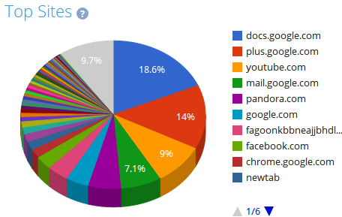

Google Chromebook Usage
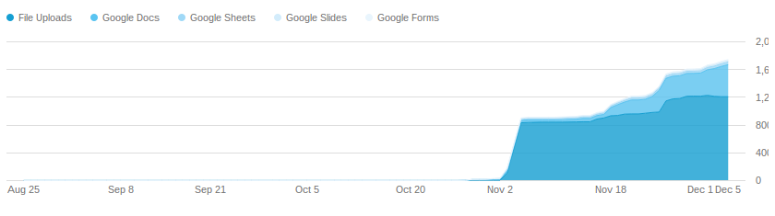

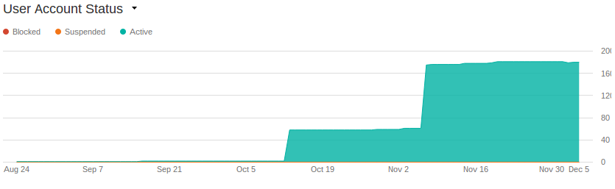

Drive32
1:1 Rollout Summary and Plan for Next Rollout

As a result of a great deal of planning, implementation and reflection, it is the desire to move forward with the next phase of 1:1 implementation as soon as possible. With key adjustments made and professional development executed, Blackduck ISD #32 is prepared to hand out devices to 7th grade students at Blackduck High School and 6th grade students at Blackduck Elementary School. In light of issues mentioned in the accompanied document, Blackduck ISD #32 is in favor of distributing Chromebooks to the 6th grade as well. In addition, to promote technological literacy and staff development, Blackduck administration has established a need to supply Chromebooks to teachers. Students throughout the building will now be using these devices, as a result, teachers must have access.

