**INDEPENDENT SCHOOL DISTRICT NO. 32**

**Blackduck PUBLIC SCHOOLS**

**156 1st St. NE**

**Blackduck, MN 56630**

**NONLICENSED PERSONNEL APPLICATION FOR EMPLOYMENT**

ISD # 32 is an equal opportunity employer, dedicated to a policy of nondiscrimination in employment on any basis including race, creed, color, age, sex, sexual orientation, religion or natural origin, marital status, or status with regard to public assistance of whatever nature or disability.

**PERSONAL DATA:** DATE:___________________SOCIAL SECURITY NO.______________________________

Name_____________________________________________________________________________________

(Last) (First) (Middle or Maiden)

Present Address_____________________________________________________________________________

(Street) (City) (State) (Zip)

Present Telephone Number ________________________________________

Military Service Dates ______________________________ Date of Discharge _________________________

Military Occupational Specialty (MOS)_________________________________________________________

**EMPLOYMENT DESIRED:**

Position_____________________________________ Date you can start ____________________________

Do you have any objection for us contacting your current employer about your employment candidacy with our school district at this time? Check one: ___ YES NO ____

**EDUCATION:**

|  |  |  |  |  |
| --- | --- | --- | --- | --- |
| **Education** | **Name & Location of School** | **Circle Last**  **Year Completed** | **Did You Graduate?** | **Subjects Studied and Degree(s) Received** |
| High School |  | 7 8 9 10 11 12 | Yes or No |  |
| College |  |  |  |  |
| Trade, Business or  Correspondence School |  |  |  |  |

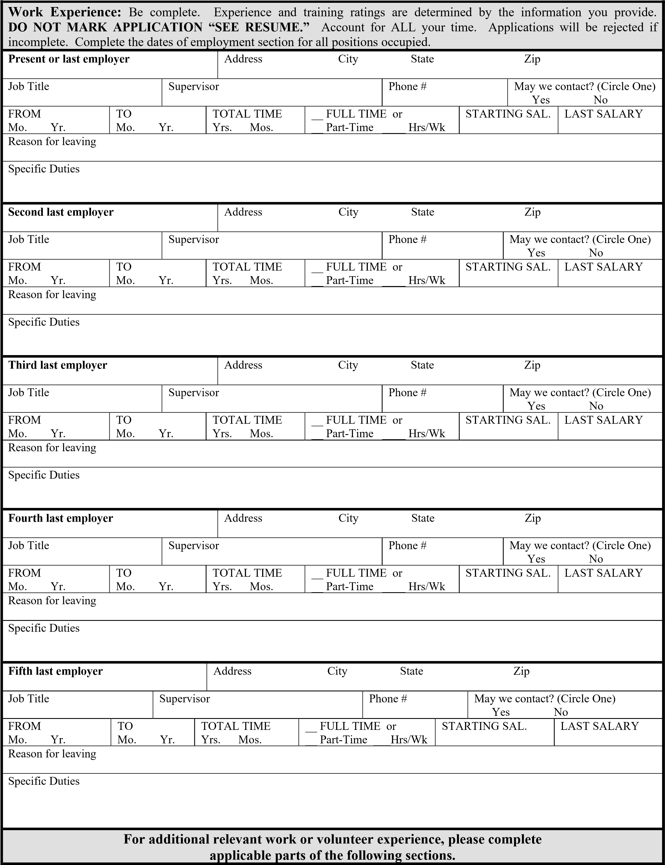

|  |  |  |  |  |  |  |  |  |  |
| --- | --- | --- | --- | --- | --- | --- | --- | --- | --- |
| **Employer** | | | | Address City State Zip | | | | | |
| Job Title | | Supervisor | | | | Phone # | | May we contact? (Circle One)  Yes No | |
| FROM  Mo. Yr. | TO  Mo. Yr. | | TOTAL TIME  Yrs. Mos. | | __ FULL TIME or  __ Part-Time ____  Hrs/Wk | | STARTING SAL. | | LAST SALARY |
| Reason for leaving | | | | | | | | | |
| Specific Duties | | | | | | | | | |
| **Employer** | | | | Address City State Zip | | | | | |
| Job Title | | Supervisor | | | | Phone # | | May we contact? (Circle One)  Yes No | |
| FROM  Mo. Yr. | TO  Mo. Yr. | | TOTAL TIME  Yrs. Mos. | | __ FULL TIME or  __ Part-Time ____  Hrs/Wk | | STARTING SAL. | | LAST SALARY |
| Reason for leaving | | | | | | | | | |
| Specific Duties | | | | | | | | | |
| **Attach additional pages of employment/volunteer information if necessary.** | | | | | | | | | |

**REFERENCES (THREE REFERENCES REQUIRED)**

|  |  |  |  |  |  |
| --- | --- | --- | --- | --- | --- |
| **Full Name** | **Address City, State Zip** | **Relationship** | **Occupation**  **(if applicable)** | **Telephone No.** | **Years Acquainted** |
|  |  |  |  |  |  |
|  |  |  |  |  |  |
|  |  |  |  |  |  |

Check if applicable: _____Disabled individual

Please indicate in this box any accommodations you may need to participate in the testing, interview, or selection process.

**VETERAN’S PREFERENCE:** If you are a Veteran or the spouse of a disabled or deceased Veteran and wish to claim Veteran’s Preference, you must provide the required documents (DD214 or disability certificate) and signature.

Please check the appropriate items if you are claiming Veteran’s Preference:

I hereby indicate that I am a: ___ Veteran ____ Disabled Veteran

Signature: _________________________________________________________________

# PLEASE READ AND SIGN

I certify that the answers I have given on this application are true and correct to the best of my knowledge. I understand that any false or misleading information provided, or any omission or concealment of facts, will disqualify me from consideration for employment and may constitute grounds for my immediate dismissal should I be employed by the Blackduck School District (ISD 32). I hereby authorize investigation of all statements contained in this application and other application or employment credentials submitted. I also authorize any and all current and former employers, organizations where I have volunteered, references named in this application, or any agent of such a current or former employer or volunteer organization, to release to ISD 32 and its agents any and all public or private information regarding my job performance, fitness, or qualifications to perform the position I am presently seeking and any other employment or related information. I understand the ISD 32 will use this information to determine my fitness and qualifications for the position I am seeking. I hereby release ISD 32 and all current and former employers, volunteer organizations, and references listed herein and any and all agents acting on behalf of ISD 32, former employers, volunteer organizations, or references from any and all liability of whatever nature by reason of requesting or providing such information.

I understand that Minnesota Statutes may require that I authorize and pay for a criminal background check should I be offered this position.

I understand, acknowledge and agree that no offer of employment is valid or binding until formal approval by the ISD 32 School Board. Until such approval, ISD 32 shall not be liable for reliance on any oral or written offers of employment made to me. I understand and agree that my employment is for no definite period and may, regardless of the date of payment of my wages and salary, be terminated at any time without any previous notice.

It is unlawful to knowingly hire any alien not authorized to work in the United States. Verification of all new hires will be by examining: 1) United States passport or 2) United States birth certificate or social security card and a driver’s license, state issued I.D. card or alien identification document.

This authorization expires one year from the date of my signature below.

**Date ____________________ Applicant’s Signature _______________________________________________**

**BLACKDUCK PUBLIC SCHOOL DISTRICT**

**PERSONAL REFERENCE CHECK FORM**

**PERSONAL REFEENCE**

Employment/work references should complete the next page.

## PERSONAL REFERENCE INFORMATION

Name:__________________________________________ Phone(s):______________________________

Address:________________________________________ City:___________________State:___________

Signature:_______________________________________ Date:)_________________________________

How long have you known this applicant? ______________________

In what capacity have you known this applicant? ______________________

What are your primary relationship(s) with this candidate?

__________________________________________________________________________________________________

__________________________________________________________________________________________________

Please rank the candidate in the following areas:

|  |  |  |  |  |
| --- | --- | --- | --- | --- |
| AREA |  |  | CIRCLE ONE |  |
| 1. Dependability/Reliability/Honesty |  | High | Acceptable Low | Not Rated |
| 2. Interpersonal Relationships |  | High | Acceptable Low | Not Rated |
| 3. Appropriate Appearance for Work  (Neatness, grooming, etc.) |  | High | Acceptable Low | Not Rated |
| 4. Work Ethic |  | High | Acceptable Low | Not Rated |

Describe qualities that would make this applicant a good Blackduck School District employee:

__________________________________________________________________________________________________ __________________________________________________________________________________________________ __________________________________________________________________________________________________ __________________________________________________________________________________________________ __________________________________________________________________________________________________ __________________________________________________________________________________________________ __________________________________________________________________________________________________

__________________________________________________________________________________________________ __________________________________________________________________________________________________ __________________________________________________________________________________________________

__________________________________________________________________________________________________ __________________________________________________________________________________________________

**BLACKDUCK PUBLIC SCHOOL DISTRICT**

**EMPLOYMENT/WORK REFERENCE CHECK FORM**

You have been asked to be a reference for a potential Blackduck School District employee. Thank you for completing this form and helping our school district assure that we continue to employ quality individuals to carry on our mission to serve our students and community.

Applicant’s Name:___________________________________________ Date of Reference Request:____________

Position(s) for which applicant is applying:________________________________________________________________

__________________________________________________________________________________________________

__________________________________________________________________________________________________

**EMPLOYMENT/WORK REFERENCE**

(Personal references (non-work related) should complete the back side of this page).

## EMPLOYMENT/WORK REFERENCE INFORMATION OF PERSON COMPLETING THIS FORM

|  |  |
| --- | --- |
| Name:__________________________________________ | Phone(s):______________________________ |
| Address:________________________________________ | City:___________________State:___________ |
| Signature:_______________________________________ | Date:)_________________________________ |

In what capacity have you known this applicant? Check all that apply.

_____ Work Supervisor _____ Co-Worker _____ Friend _____ Other (Explain) ______________________________________________________________________________________

How long have you known this candidate? ____________________

Candidate’s work assignment/areas of responsibility:

__________________________________________________________________________________________________

__________________________________________________________________________________________________

Please rank the candidate in the following areas:

AREA CIRCLE ONE

1. Dependability/Reliability/Honesty High Acceptable Low Not Rated
2. Attendance High Acceptable Low Not Rated
3. Quality of Work High Acceptable Low Not Rated
4. Relationship with Co-Workers High Acceptable Low Not Rated
5. Relationship with Clients/Customers High Acceptable Low Not Rated
6. Appropriate Appearance for Work High Acceptable Low Not Rated

Would you recommend this candidate for hire in the position(s) stated above? Circle one: Yes No

Reason for leaving this position, if known:___________________________________________________________

Additional Comments (if any):__________________________________________________________________________

__________________________________________________________________________________________________